Project Development Phase
Model Performance Test
Date | 28 September 2026
Team ID | 6ab221d587602313e82c60c9
Project Name | Project - Import Data using Transform Maps (Spreadsheet)
Maximum Marks

Model Performance Testing:
Project team shall fill the following information in model performance testing template.
S.No. | Parameter | Values | Screenshot
1. | Model Summary | Employee data from a spreadsheet is loaded into a ServiceNow staging (import set) table and moved to the target table using a Transform Map. Source File - , Target Table - , Coalesce Field - | 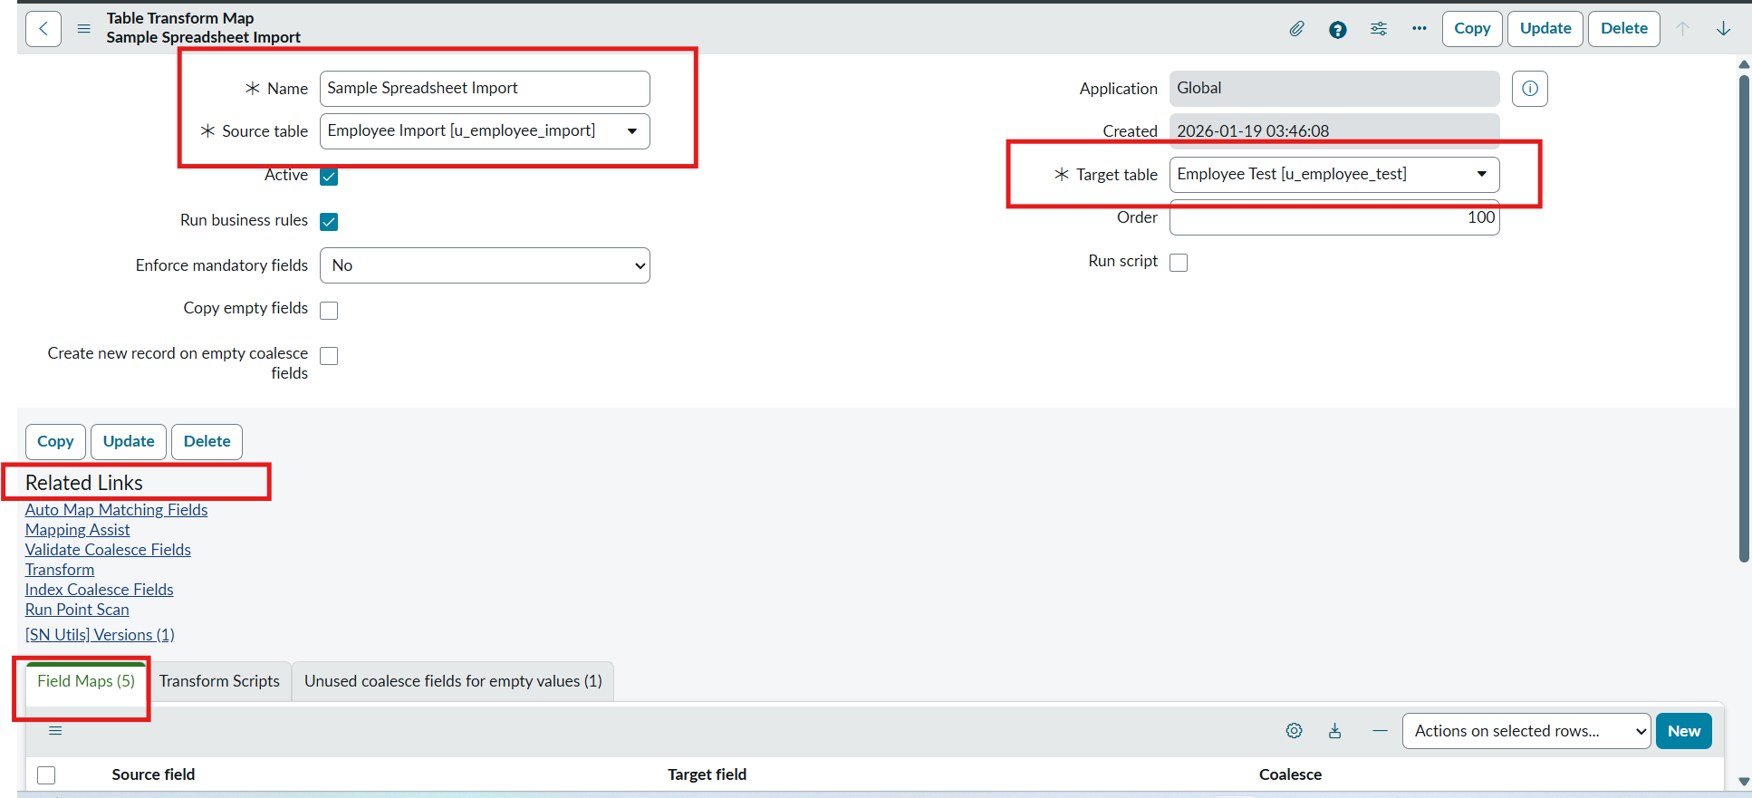
2. | Accuracy | Training Accuracy (Import Accuracy: rows transformed correctly / total rows) -  Validation Accuracy (Target table records matching source data) - |   
3. | Fine Tuning Result( if Done) | Validation Accuracy (after adjusting field mappings / coalesce / transform script) - |     

